Minor Project Report on

**Web Technology**

**Title: Digital Magazine**

Submitted to Manipal University, Jaipur

Towards the partial fulfilment of the Award of the Degree of

**BACHELOR OF TECHNOLOGY**

In Computers Science and Engineering

2023-2024

By

Ojasvi Padhiar

Registration Number:229301684

Under the guidance of

Dr Shikha Mundra

**Department of Computer Science and Engineering**

**School of Computer Science and Engineering**

**Manipal University Jaipur**

**Jaipur, Rajasthan**

**Introduction**

In the current era of rapid technological development and ever-evolving digital landscape, the fusion of art and technology has emerged as a new form of creative expression that captivates and inspires. This digital magazine serves as a testament to the innovative fusion of artistic talent and digital design, celebrating the multidisciplinary approach of modern creators and offering readers an immersive journey through various forms of digital art and design.

The magazine features a diverse range of artistic endeavors, including striking visual designs, interactive art installations, and immersive digital experiences. It highlights the works of artists who push the boundaries of traditional art, exploring new ways to captivate audiences and convey compelling stories in an increasingly digitized world.

In addition to showcasing stunning imagery and thought-provoking pieces, the magazine provides a platform for creators to share their insights and inspirations. By delving into the minds of talented artists, readers can gain a deeper understanding of their creative processes and the inspirations that drive their work.

Designed to be an engaging and interactive experience, the digital magazine utilizes modern web technologies to bring art to life. With a seamless navigation experience, readers can explore different sections that focus on specific themes and artistic styles, showcasing the most innovative and impactful works in the digital art world.

In the midst of the digital transformation that has swept the world, this magazine stands as a testament to the power of creativity and technology working hand in hand. It encourages readers to experience the future of art and design, where imagination knows no bounds and every piece is a unique expression of the artist's vision. Through this digital magazine, we celebrate the artists who inspire us, challenge us, and leave us in awe with their groundbreaking work.

**Language Used**

The popularity of visually appealing and interactive digital magazines has skyrocketed in recent times. This project presents a digital magazine created using **HTML, CSS,** **JavaScript, PHP and MySQL** that provides an immersive and seamless reading experience. The responsive and modern layout of the magazine features multiple sections with unique visuals and text. CSS is responsible for styling the magazine, including fonts, colours, and layout adjustments. The project also employs JavaScript and external libraries such as GSAP and Locomotive Scroll to introduce animations and smooth scrolling effects, resulting in an interactive and dynamic user experience. By leveraging the capabilities of modern web technologies, this project showcases an exceptional reading experience that is both captivating and engaging.

Languages Used in This Code

The digital magazine project uses various programming languages and web technologies to create an engaging and dynamic experience for readers. Each language serves a specific purpose, from organizing content to managing data and handling interactivity.

Here are the details of the languages used:

1. **HTML**: Hypertext Markup Language (HTML) structures the digital magazine. It includes text, images, and multimedia elements.
2. **CSS**: Cascading Style Sheets (CSS) add style to the magazine, including layout, typography, colours, and other aesthetic elements.
3. **JavaScript**: JavaScript makes the magazine interactive and dynamic. It powers features such as animations, navigation, and multimedia content.
4. **Back-End Languages**:

* **PHP**: PHP manages server-side operations such as content management and user authentication.

1. **Database**:

* **MySQL**: MySQL stores and manages data for the digital magazine, including user information and content.

These languages and technologies create a seamless and immersive experience for readers.

**Webpages**

1. **COVER PAGE :**

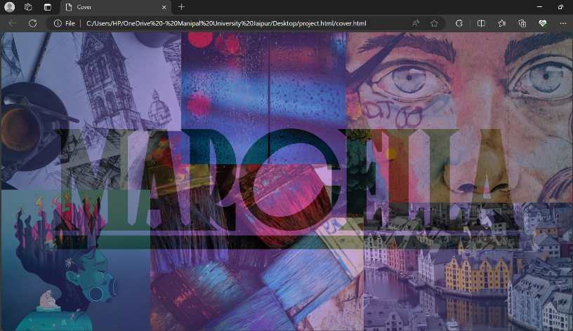

This web page functions as an introduction or cover page for a digital magazine project entitled "MARCELLA." The page boasts a visually appealing design with a clear emphasis on branding. The following are the primary components and features of the aforementioned web page:

* 1. Document Type Declaration (`<!DOCTYPE php>`):The document initially declares an HTML5 structure. However, the declaration itself is erroneous, as it opts for `<!DOCTYPE php>` instead of `<!DOCTYPE html>`, which is the correct declaration for an HTML document.
  2. HTML Structure (`<html>` to `</html>`): The page follows a standard HTML structure, with the language attribute set to English.
  3. Head Section (`<head>`):
     + Meta Charset (`<meta charset="UTF-8">`): This ensures the page's UTF-8 encoding for character representation.
     + Viewport Meta Tag (`<meta name="viewport" content="width=device-width,initial-scale=1.0">`): This configures the page to adjust to varying screen sizes and devices, ultimately providing responsive design.
     + Title (`<title>`): The title of the page is "Cover."
     + CSS Styling (`<style>`): This page features inline CSS styles that dictate the visual appearance. These styles define the layout, fonts, background images, gradients, and text colours.
  4. Body Section (`<body>`):
     + Background (`<body>`):The body has a background image that covers the entire viewport and is located centrally on the page.
     + Flexbox Layout:The body uses a flexbox layout to center its content.
     + Main Content (`<div class="image">`):
     + The primary content is contained within a div element with the class `image`.
     + The div features a radial gradient as its background and is partially transparent.
     + Within the div, a hyperlink leads the user to the login page. The link comprises an `h1` element that features the magazine's name, "MARCELLA," in large text.

In summary, this web page serves as an initial entry point to the digital magazine and presents the user with a visually appealing design that heavily emphasizes branding.

1. **LOGIN / REGISTRATION PAGE:**

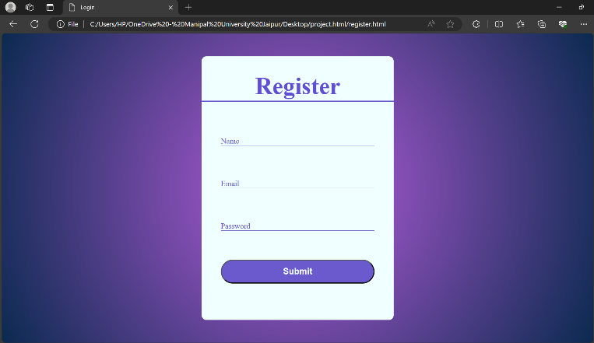

The provided code snippet includes two web pages that serve distinct yet complementary purposes: one for user authentication and another for registration. The login page is implemented with PHP, using a MySQL database for user authentication, and a JavaScript function to validate user inputs. In contrast, the registration page uses a simple form for users to provide their name, email address, and password, directing the submission to a server-side PHP file.

Both pages share a consistent design pattern with a focus on simplicity, clarity, and user-friendliness. They feature a background with a radial gradient effect and a colour scheme that centres around slate blue and white. Forms are centred on the page and utilize labelled input fields for user information entry.

Overall, the code provides a solid foundation for user authentication and registration processes. With further development and optimization, it can offer an even better user experience.

1. **MAIN PAGE:**

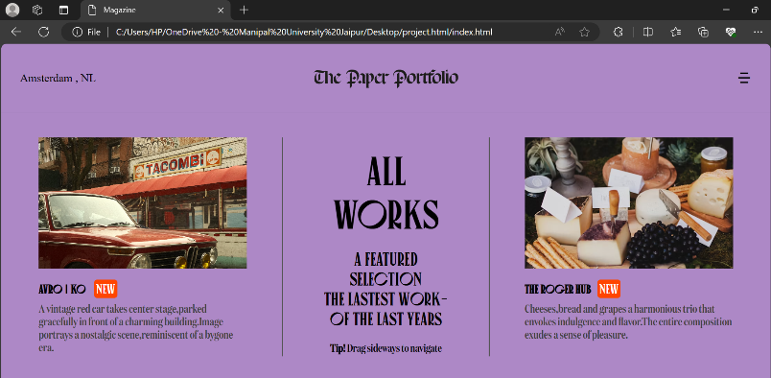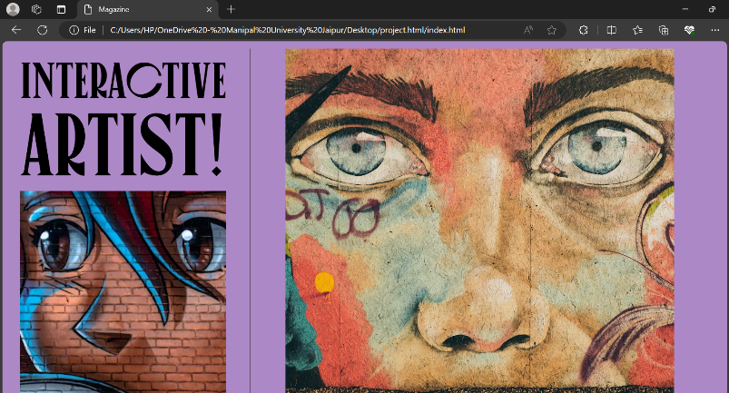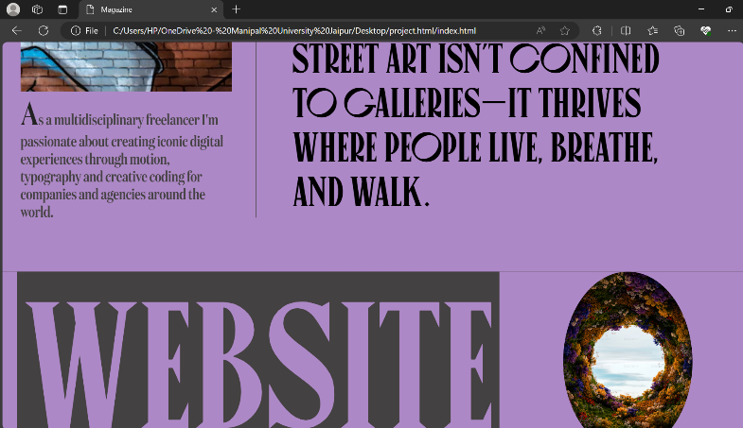

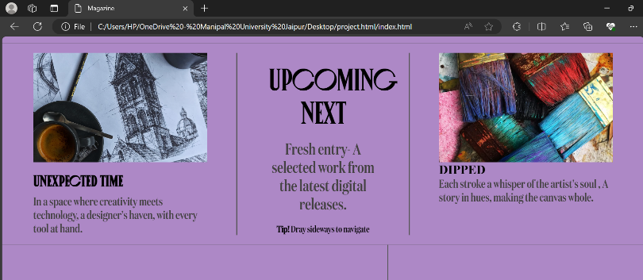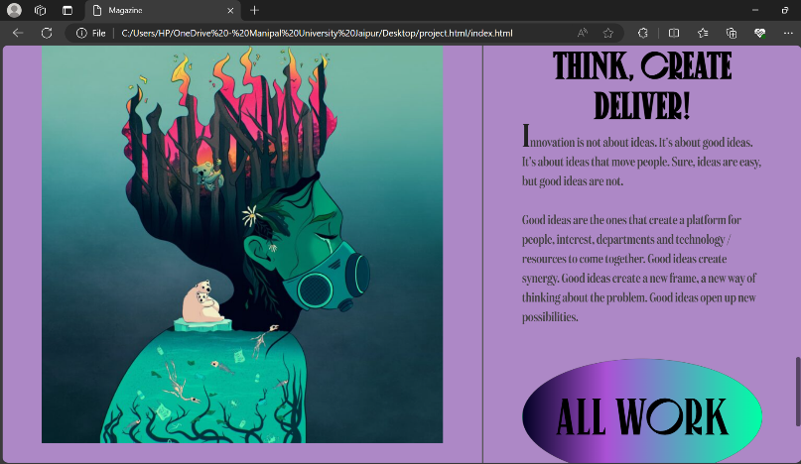

The web page for a magazine-style website that showcases various works, art, photography, and design projects. The webpage contains a multi-section layout and uses multiple third-party libraries for smooth scrolling and animations.

Here's a summary of the different parts of the web page and its features for my project report:

**Structure and Content:**

1. Head Section: Contains metadata for the web page, including the title, charset, and links to stylesheets and external libraries.
2. Body Section: Contains the main content and interactive elements of the web page, divided into various sections:
   * + Page 1: The main landing page with a navigation bar, a large header ("MARCELLA"), and featured works with images and descriptions. The page includes smooth scroll and animation features for a dynamic user experience.
     + Page 2: Showcases an interactive artist, with descriptions, images, and an inspirational quote.
     + Page 3: Features a single large title ("WEBSITE") with an image overlay, providing an artistic and minimalist design.
     + Page 4: Highlights upcoming works with images and descriptions, and also includes navigation tips for the user.
     + Page 5: Describes the concept of "think, create, deliver," focusing on the importance of innovation and creativity. This section features images and descriptive text.
     + Page 6: A call-to-action section inviting users to create something together, with the option to email the creators. It includes scrolling text animation.
     + Page 7: A contact section providing phone and email details for reaching out.

**External Libraries and Features:**

* + 1. Remix Icon Library: Used for adding icons to the page.
    2. Locomotive Scroll: Provides smooth scrolling for the webpage.
    3. GSAP (GreenSock Animation Platform: Utilized for animations on the web page.
    4. Custom CSS: The page uses a custom stylesheet (`style.css`) to style elements such as fonts, colours, and layout.

**Custom Features:**

* + 1. Animation and Scrolling: The page uses animation timelines and keyframes to create smooth transitions and dynamic effects throughout the web page, creating a visually engaging experience.
    2. Interactive Sections: The page is designed to be interactive, encouraging user engagement through animations, transitions, and visual effects.
    3. Aesthetic Design: The design elements like fonts, colours, and the minimalist layout enhance the artistic presentation of the web page.

In summary, this web page provides a magazine-style, interactive experience showcasing various art and design projects with smooth scrolling, animations, and a visually appealing layout.

Database table

